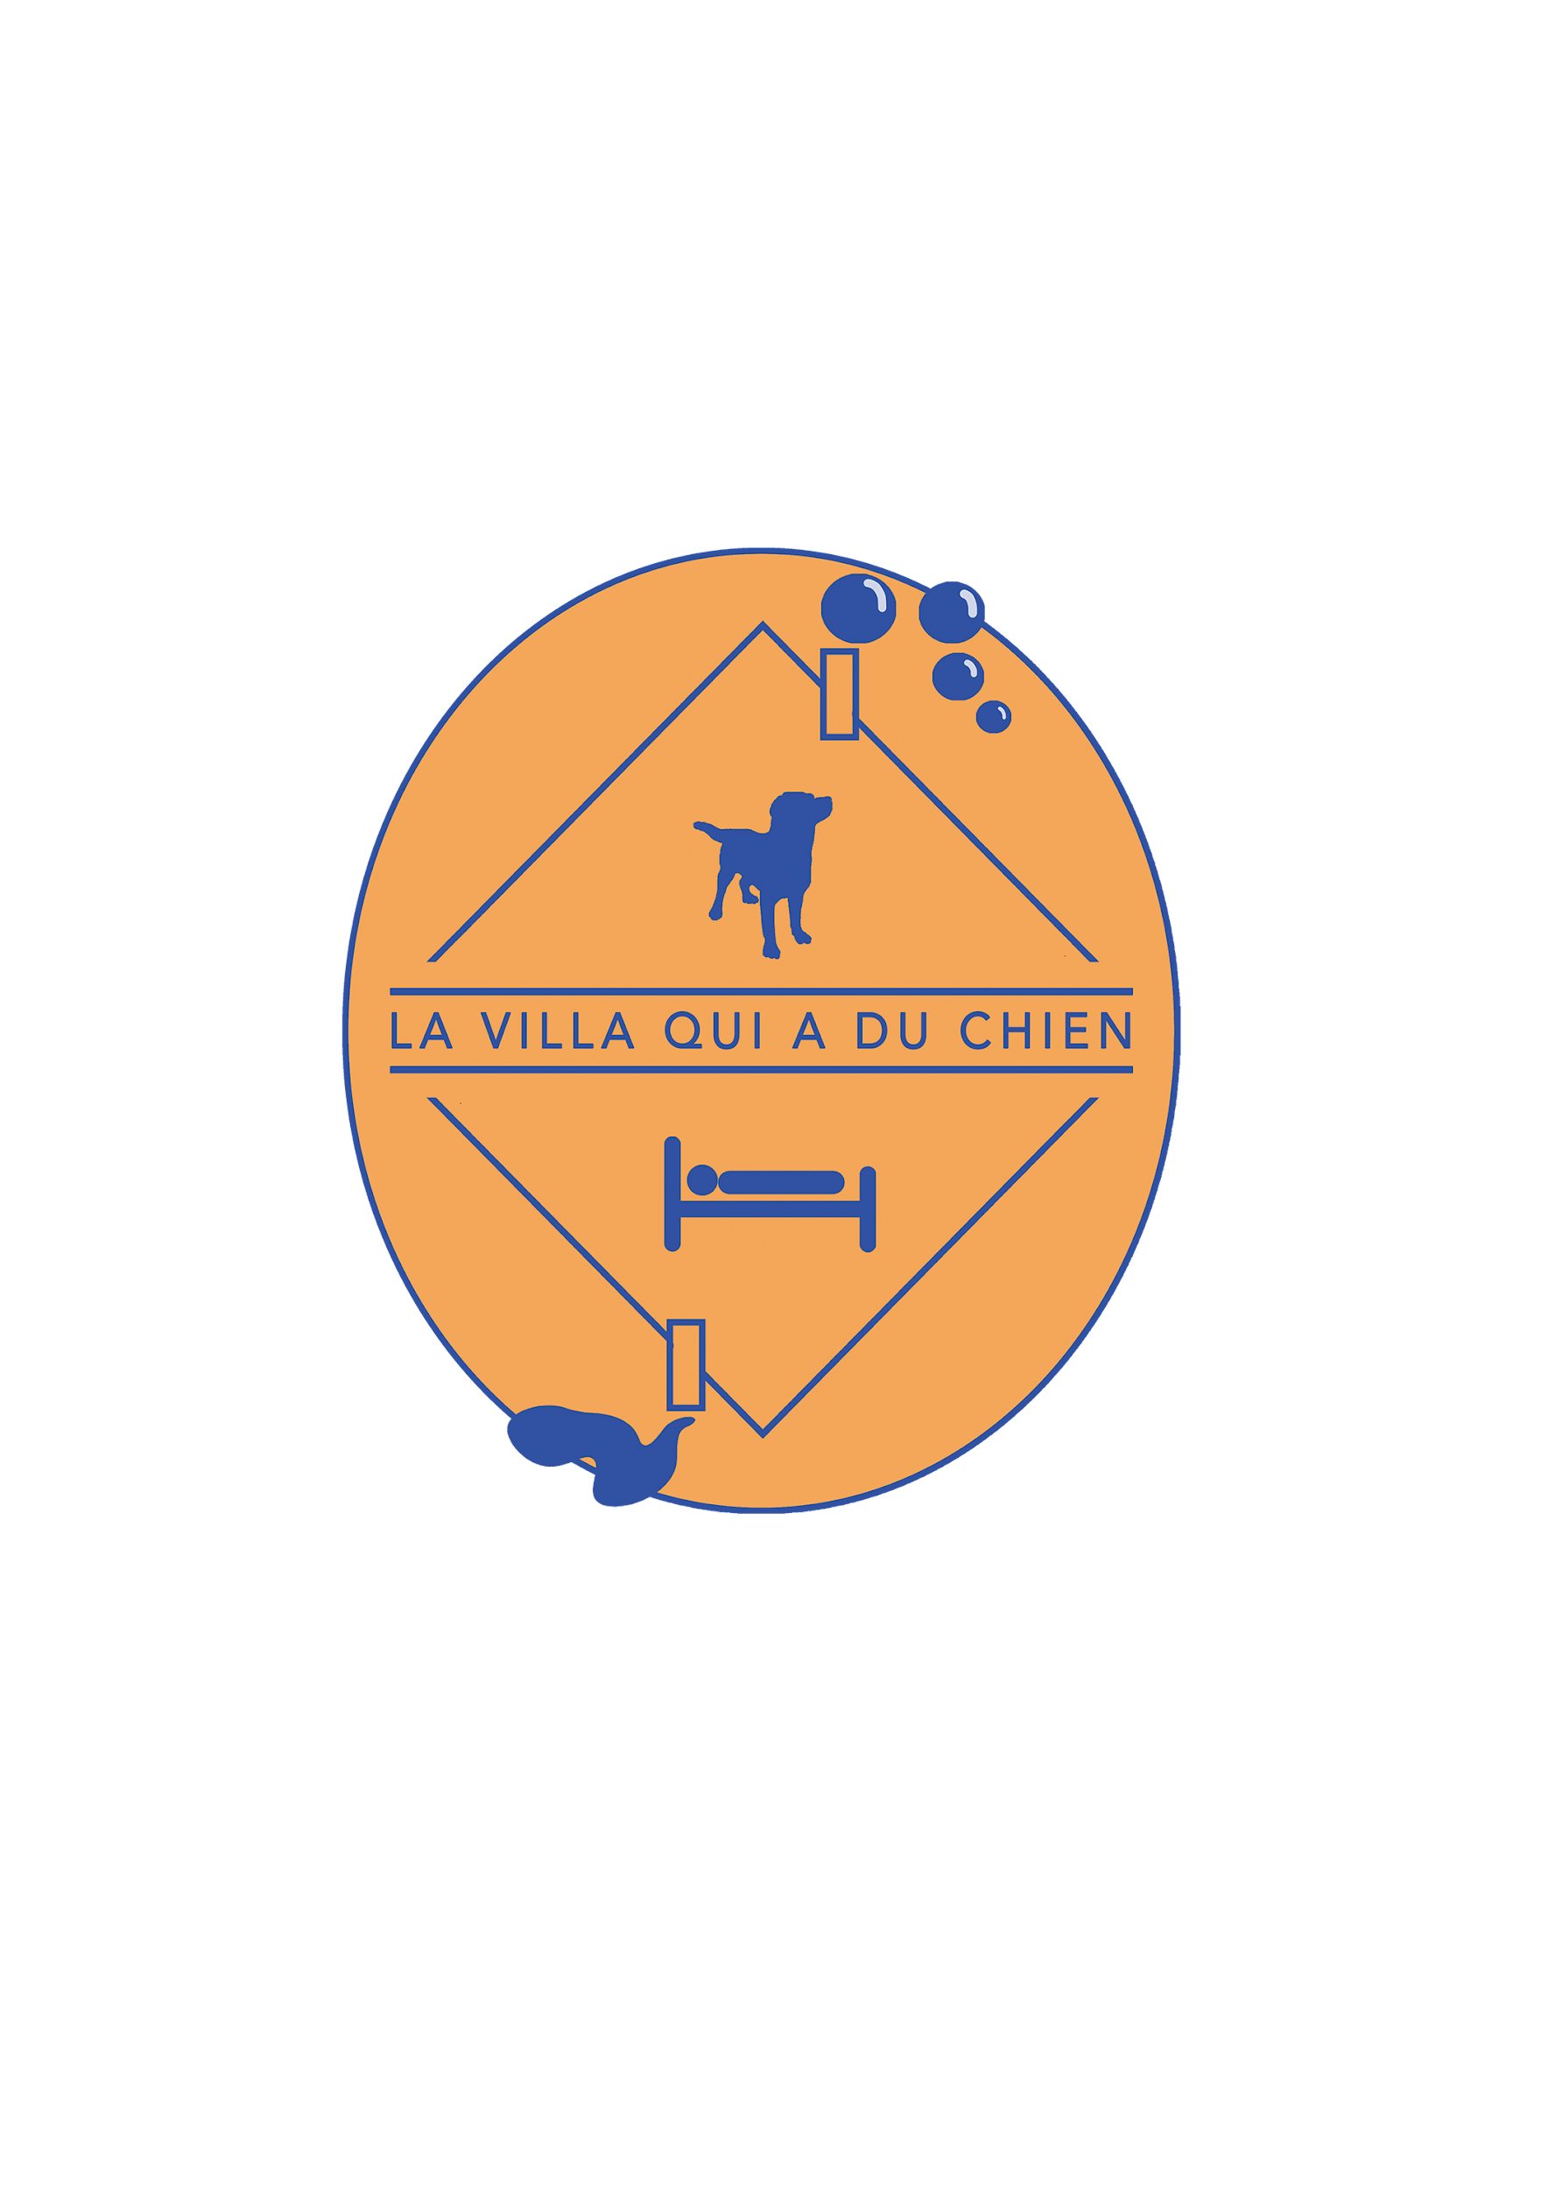

**Legal information and general** **conditions of use of the web page La Villa qui a du Chien**

**Identification and activity:**

The [site www.lavillaquiaduchien.com](http://www.lavillaquiaduchien.com) belongs to La Villa qui a du Chien, managed by Sylvie Mulder:

* **Company name**: The Villa qui a du Chien
* **Address**: Le Jardinet, 61120 Neuville sur Touques
* **Manager and responsible for the edition of the site**: Sylvie Mulder
* **Phone**: +33 9.84.20.35.19
* **Email**: [lavillaquiaduchien@gmail.com](mailto:lavillaquiaduchien@gmail.com)
* **Registration** number **in the Trade and Companies** Register: SIREN nº 909 661 985
* **Individual tax identification** number: SIRET n° 909 661 985 00012
* **Host**:
  + Wix
  + Wix Online Platform Limited
  + Address: 1 Grant's Row, Dublin 2 D02HX96, Ireland.
  + Phone: Please click [here](https://support.wix.com/en/article/contacting-wix-by-phone-3491545).

**Use of cookies:**

**What** is **a cookie?**

A cookie is a computer tool that makes it possible to track and analyze the behavior of a user on the Internet (his navigation on the Internet, on a site, in an application, etc.).

Cookies subject to the consent of Internet users are those intended to personalize advertisements and those related to social networks.

**What types of cookies do we use and why?**

The cookies we use on our website are grouped into two main categories:

* Category 1: Strictly necessary cookies

Cookies essential for the proper functioning of the website and its functionalities. Without these cookies, the booking services (grooming, family dog boarding, and/or bed and breakfast) and payment services (family dog boarding and/or bed and breakfast) cannot not be realized.

* Category 2: Performance cookies

These cookies collect anonymous data relating to the navigation of Internet users on our website, in order to improve and optimize its use. This data allows us in particular to know which pages are the most visited, which languages of navigation are used, what is the time spent on each page, which spaces generate the most clicks and shares, or what is the origin of the traffic.

**How do I disable cookies?**

Internet users have the possibility to disable third-party cookies by following the recommendations  [of the CNIL](https://www.cnil.fr/fr/cookies-les-outils-pour-les-maitriser).

**Privacy Policy :**

Document also available on the [website of La Villa qui a du Chien](https://www.lavillaquiaduchien.com/_files/ugd/f99e6d_cc1a8e42cdf64f3d94c5a806b710d29c.pdf) (section "Legal Documents" of the web page).

**Responsible for the processing of personal** **data:**

La Villa qui a du Chien, SASU. To exercise your rights or address your questions regarding the personal data processed by La Villa qui a du Chien, please send an email to [lavillaquiaduchien@gmail.com](mailto:lavillaquiaduchien@gmail.com) specifying in the subject "Personal data".

**Legal** basis: The legal basis for the processing of data is the consent expressly indicated by the user of the acceptance of the conditions of the privacy policy detailed below.

**For what purpose does La Villa qui a du Chien collect your data?**

La Villa qui a du Chien exclusively processes your data for the management of its services of guest rooms, family dog boarding and grooming, with the aim of ensuring a quality service that best meets the needs of customers.

The Villa that has Dog will use your data to manage your booking requests (confirmations and changes of reservations as well as sending invoices) and customize its services according to needs and preferences indicated.

**The data collected is as follows:**

* **Personal data**: first name, last name, email, telephone.
* **Additional data for the execution of the contracted** **service**: type of service contracted (guest rooms, family canine pension and / or grooming), date and time of reservation, chosen rate formula.
* **Additional data required for any reservation of the family canine boarding** **service**  : data of the [Family](https://www.lavillaquiaduchien.com/_files/ugd/f99e6d_99bd445cb97745da91e5c4126077c7dd.pdf) Dog [Boarding](https://www.lavillaquiaduchien.com/_files/ugd/f99e6d_99bd445cb97745da91e5c4126077c7dd.pdf) [Contract](https://www.lavillaquiaduchien.com/_files/ugd/f99e6d_99bd445cb97745da91e5c4126077c7dd.pdf), including the data of an emergency contact and the data relating to the characteristics of the boarding dog(s).

**Mandatory** **nature of data collection:**

La Villa qui a du Chien reserves the right to refuse the provision of its services if the customer does not provide the data indicated or communicates erroneous data.

**Recipient of the data collected:**

The staff of La Villa qui a du Chien, for the realization of the reserved services.

**How long will** **La Villa qui a du Chien keep your data?**

La Villa qui a du Chien will keep the booking data provided by the customer for 6 months. They are considered as proof of the customer's consent to book one or more services of La Villa qui a du Chien.

**How to exercise your rights granted by the**  [**European General**](https://www.itgovernance.eu/fr-fr/eu-general-data-protection-regulation-gdpr-fr) [**Data**](https://www.itgovernance.eu/fr-fr/eu-general-data-protection-regulation-gdpr-fr) [**Protection Regulation**](https://www.itgovernance.eu/fr-fr/eu-general-data-protection-regulation-gdpr-fr) **(GDPR)?**

To exercise your right of access, rectification, erasure, limitation of processing, portability or opposition, please send an email to [lavillaquiaduchien@gmail.com](mailto:lavillaquiaduchien@gmail.com) (specifying in the subject "Personal Data") as soon as possible so that La Villa qui a du Chien can process your request as soon as possible.

Reminder: you also have the right to lodge a complaint with the CNIL.