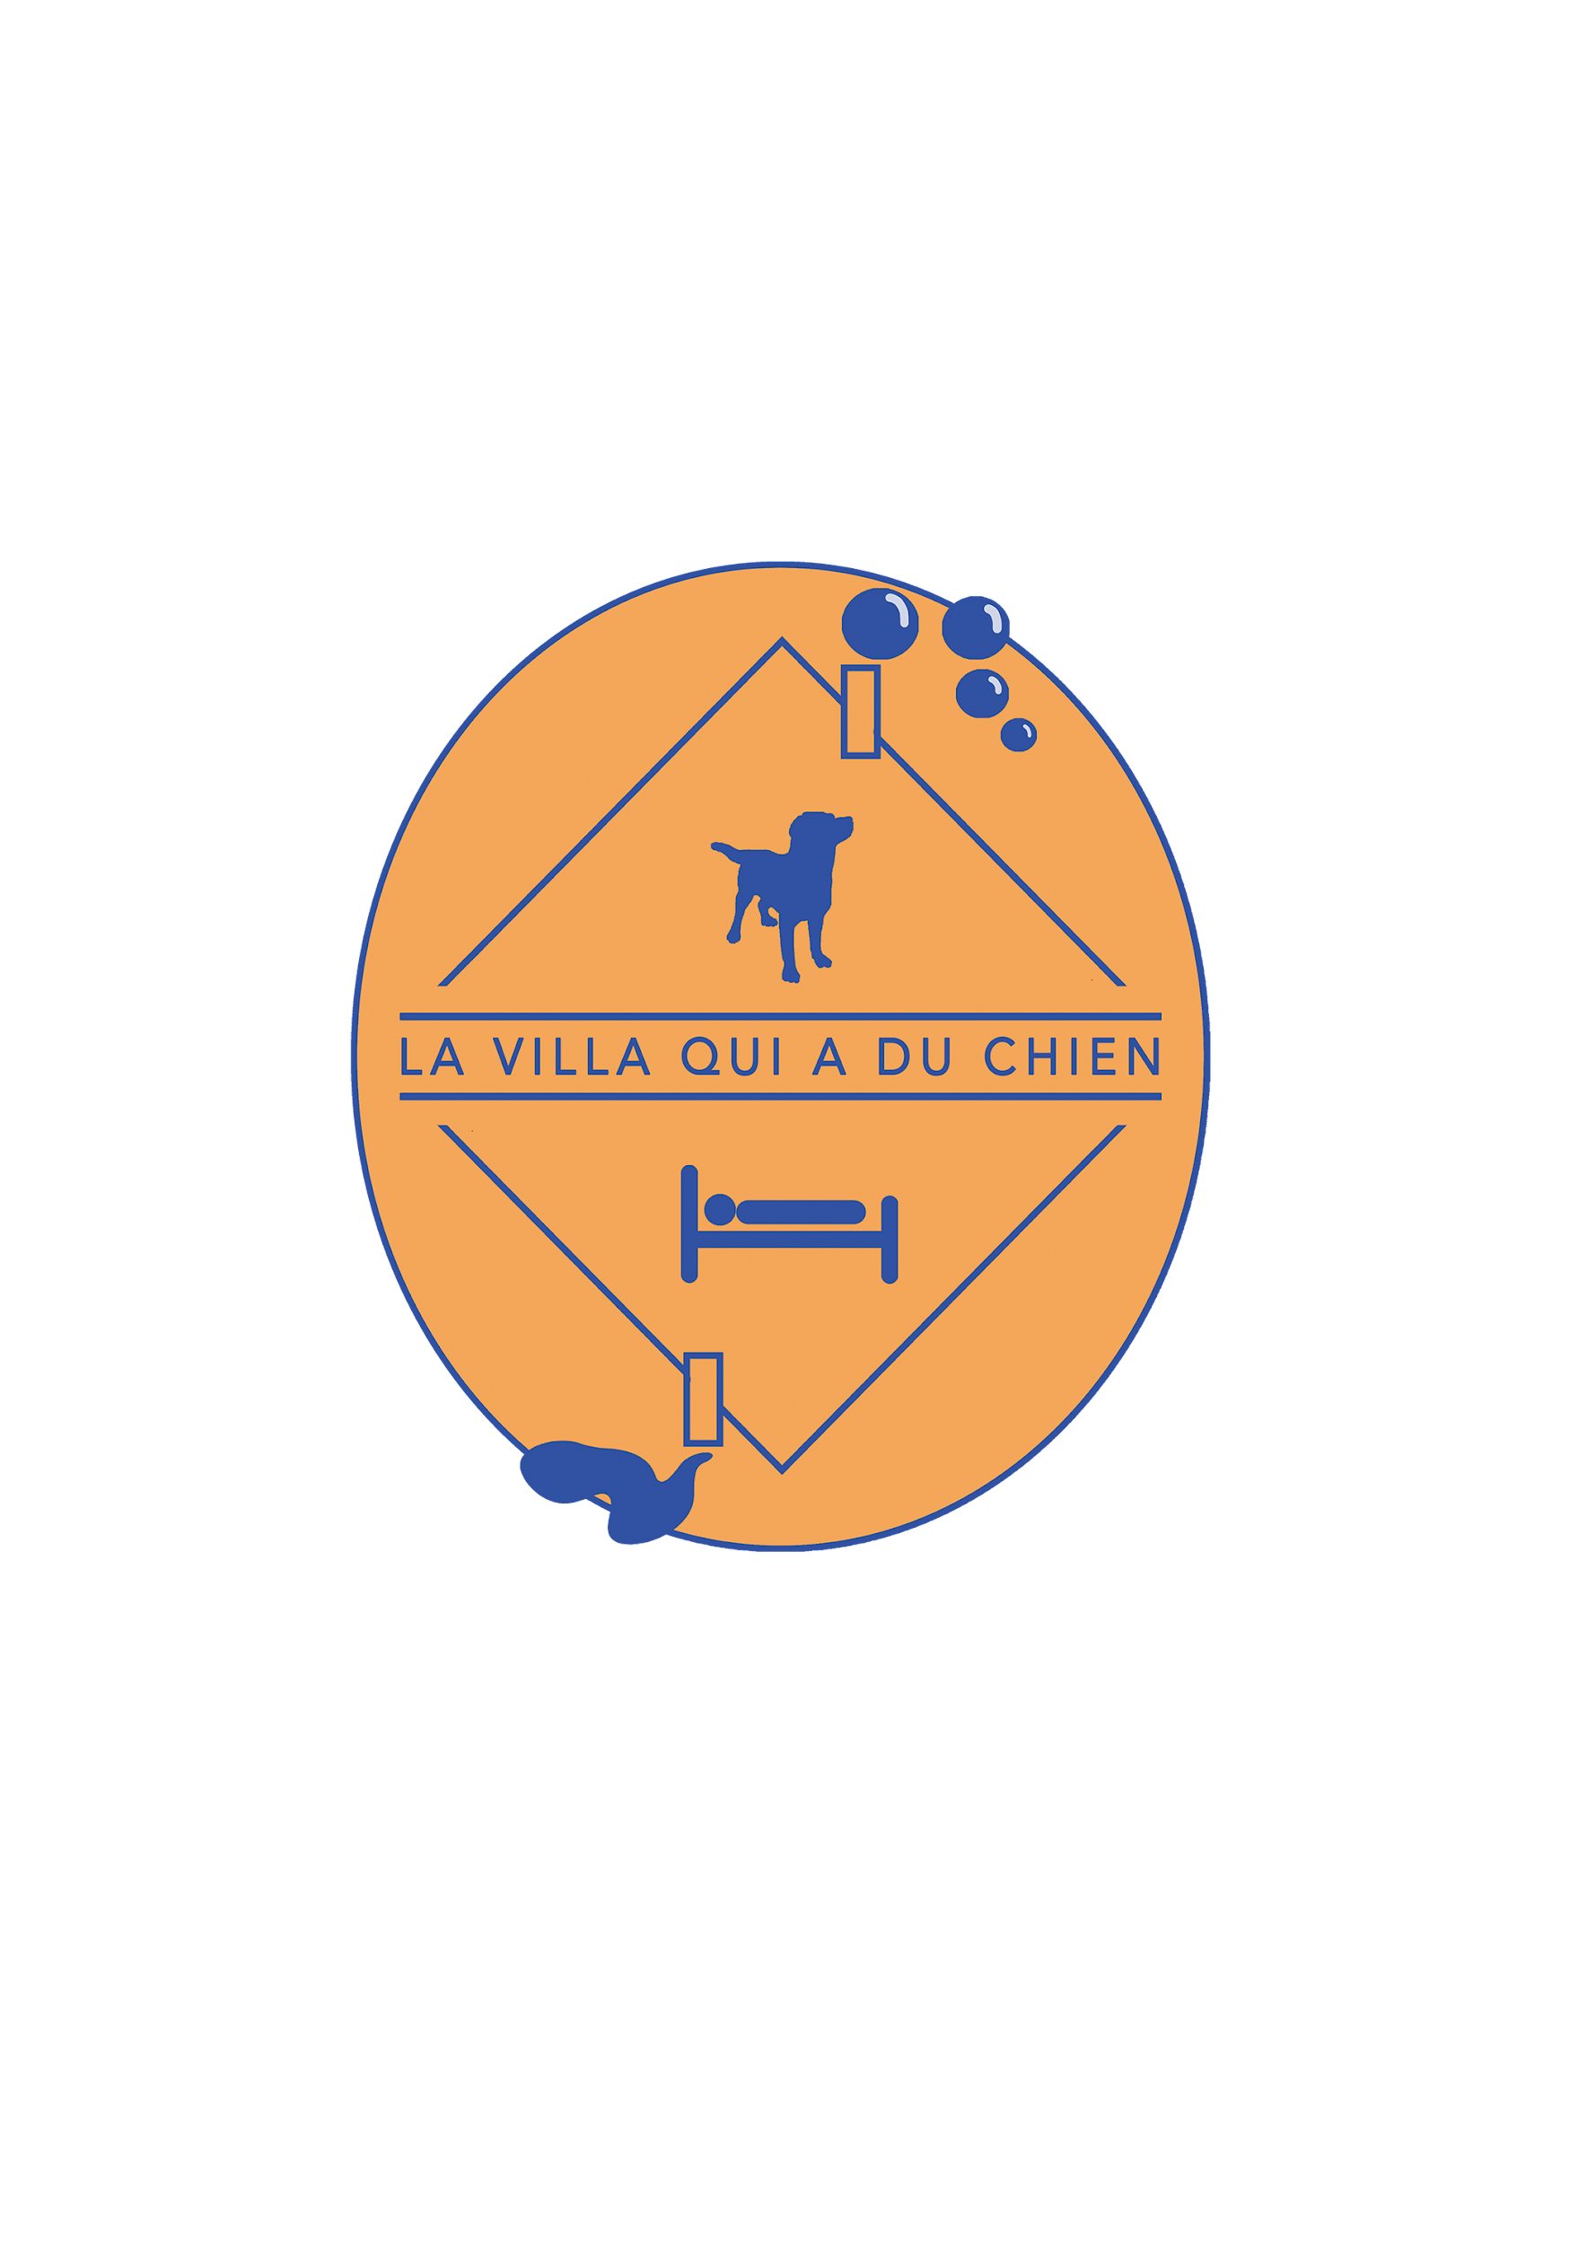

**Privacy Policy Terms of La Villa qui a du Chien**

**Responsible for the processing of personal data:**

La Villa qui a du Chien, SASU. In order to exercise your rights or answer your questions regarding the personal data processed by La Villa qui a du Chien, please send an email to [lavillaquiaduchien@gmail.com](mailto:lavillaquiaduchien@gmail.com) stating in the topic "Personal Data".

Legal basis: The legal basis for processing data is the consent explicitly stated by the user of the acceptance of the terms of the privacy policy described below.

**For what purpose does La Villa qui a du Chien collect your data?**

La Villa qui a du Chien processes only your data for managing its services of rooms, family dog boarding and grooming with the aim of ensuring a quality service that best meets customer needs.

However, La Villa qui a du Chien will use your data to manage your booking requests (confirmations and changes to bookings as well as sending invoices) and customize its services as needed and preferences indicated.

**The data collected are as follows:**

* **Personal data**: first name, surname, e-mail, telephone.
* **Additional data to perform the agreed service**: contracted service type (rooms, family dog boarding and/or grooming), date and time of booking, chosen rate formula.
* **Additional data required for any reservation of the family's dog boarding service**: data in [the Family Dog Boarding Contract](https://www.lavillaquiaduchien.com/_files/ugd/f99e6d_99bd445cb97745da91e5c4126077c7dd.pdf), including data for an emergency contact and information about the characteristics of the boarding dog(s).

**Mandatory** **nature** **of data collection:**

However, La Villa qui a du Chien, reserves the right to refuse the provision of its services if the customer does not provide the specified data or discloses erroneous data.

**Recipient of the collected data:**

The staff of La Villa qui a du Chien, for the realization of the reserved services.

**How long will** **La Villa qui a du Chien keep your data?**

La Villa qui a du Chien stores the booking data from the customer for 6 months. They are considered proof of customer consent to order one or more services by La Villa qui a du Chien.

**How do you exercise your rights under** [**the European General Data Protection Regulation**](https://www.itgovernance.eu/fr-fr/eu-general-data-protection-regulation-gdpr-fr) **(GDPR)?**

In order to exercise your right of access, rectification, deletion, limitation of processing, portability or objection, please send an email to [lavillaquiaduchien@gmail.com](mailto:lavillaquiaduchien@gmail.com) (stating in the subject "Personal data") as soon as possible so that La Villa qui a du Chien can process your request as soon as possible.

Reminder: You also have the right to lodge a complaint with the CNIL.